Precipitation Reactions

Precipitation reactions explain the formation of many insoluble ionic compounds such as enamel in teeth, kidney stones, and many minerals. In addition, in water treatment, it is common to remove a toxic ion such as Pb2+ from water by forming an insoluble compound with Pb2+.

The general form of a precipitation reaction is:

$$Soluble Ionic Compound+Soluble Ionic Compound→Insoluble Ionic Compound+Soluble Ionic Compound$$

In these exercises we have ions in water. For example, you might have K+ ions and Cl- ions in water. Say that the instructions state that you want to remove Cl- ions from the water by turning the Cl- ions into a solid ionic compound.

You will be given a list of three ionic compounds that you can add to accomplish this task. Use the solubility rules to select a compound that is soluble in water but forms a solid ionic compound with Cl-.

**Example**

You have K+ and Cl- ions in water. Which of the following compounds would cause Cl- to form an insoluble ionic compound?

1. NaBr
2. NH4I
3. AgNO3

Answer: Cl- forms and insoluble compound (AgCl) with Ag+ ions. The other two compounds do not form insoluble compounds with the Cl- ion. We can represent the reaction in any of the three ways below. The third equation below is called the net ionic equation. It omits the spectator ions.



$${Ag}^{+}+{NO}_{3}^{-}+K^{+}+{Cl}^{-}→AgCl \left(s\right)+K^{+}+{NO}_{3}^{-}$$

$${AgNO}_{3} \left(aq\right)+KCl \left(aq\right)→AgCl \left(s\right)+{KNO}_{3} (aq)$$

$${Ag}^{+}\left(aq\right)+ {Cl}^{-}→AgCl (s)$$

**Solubility Rules**

Wikipedia has an extensive solubility chart:

<https://en.wikipedia.org/wiki/Solubility_chart>

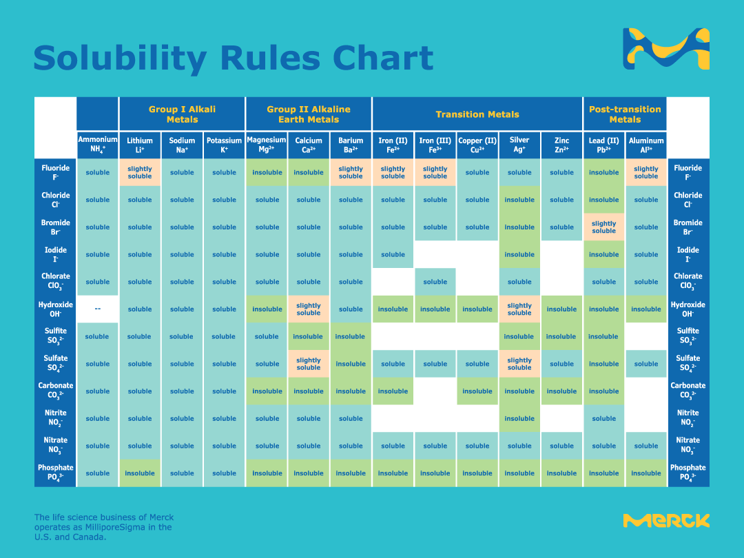

Other Solubilty Rules from the Internet:

Oxalates are highly insoluble, except for Na+, K+ and NH4+. Even rubidium and cesium oxalate are insoluble.

Oxides (O2-) are usually insoluble. Exceptions include Na2O, K2O, SrO, and BaO, which are soluble, and CaO, which is slightly soluble. 3. Hydroxides (OH-) are usually insoluble.

Rule: Chromate salts are frequently insoluble, including PbCrO4 and BaCrO4. Exception: Group I chromate salts are soluble. Rule: Phosphates are often frequently insoluble, including Ca3(PO4)2, Ag2PO4. Rule: Fluoride salts are frequently insoluble, including BaF2, MgF2 and PbF2.

**Exercises**:

|  |  |  |  |  |
| --- | --- | --- | --- | --- |
| Exercise | Ions In Solution | Instructions | Choose the Compound to Add | Write the Net Ionic Equation  This will be an in-class assignment on paper |
| 1 | Cl-  K+ | Remove the chloride ion. | AgBr  MgCO3  Hg2(NO3)2 |  |
| 2 | Na+, Na+ | Remove the oxalate ion. | CaSO4  CaCl2  KCl |  |
| 3 | K+  F- | Remove the fluoride ion. | MgSO4  CuSO4  Ca3(PO4)2 |  |
| 4 | Al3+  Cl-, Cl-, Cl- | Remove the aluminum ion. | NaOH  Ba3(PO4)2  KClO3 |  |
| 5 | Na+, Na+ | Remove the carbonate ion. | NH4I  Fe(OH)3  CaO |  |
| 6 | Pb2+  , | Remove the lead ion. | ZnClO4  Na3PO4  NiS |  |
| 7 | Ca2+  Br-, Br- | Remove the calcium ion. | K2CO3  MgCl2  NH4C2H3O2 |  |
| 8 | K+ | Remove the nitrate ion. | FeCl3  Al2(SO4)3  Ag2CO3 |  |
| 9 | Fe3+  Cl-, Cl-, Cl- | Remove the iron (III) ion. | KSCN  NaOH  LiC2H3O2 |  |
| 10 | Na+, Na+, Na+ | Remove the phosphate ion. | NH4F  KI  CaCl2 |  |
| 11 | K+, K+, K+ | Remove the arsenate ion. | FeCl3  NaBr  KF |  |
| 12 | Cd2+ | Remove the cadmium ion. | NaC2H3O2  K2SO4  Na2S |  |
| 13 | Cr3+  SCN-, SCN-, SCN- | Remove the chromium ion. | NaOH  KClO4  Na2SO4 |  |
| 14 | Li+ | Remove the perchlorate ion. | CuO  AlBr3  Ca(OH)2 |  |
| 15 | Ag+ | Remove the silver ion. | NaCl  KF  Ca(ClO4)2 |  |
| 16 | K+, K+ | Remove the chromate ion. | KCl  LiBr  BaCl2 |  |
| 17 | OH-  Na+, Na+, Na+, Na+ | Make tooth enamel. | NaOH  Ca(NO3)2  KBr |  |
| 18 | OH-  Na+, Na+, Na+, Na+ | Make the mineral Clinoclase | CuCl2  KC3H3O2  NaI |  |
| 19 | Hg2+  , | Remove the mercury (II) ion. | K2S  KBr  NaCl |  |
| 20 | , | Remove the mercury (I) ion. | Na2CO3  KClO4  LiNO3 |  |

|  |  |  |
| --- | --- | --- |
| Exercise | Answer | Net Ionic Equation  This will be in-class on paper. |
| 1 | No: AgBr is insoluble. It won’t provide enough Ag+ ions to precipitate Cl-.  No: MgCO3 is insoluble. Even if it were soluble, MgCl2 is soluble.  Yes: Hg2(NO3)2 is soluble, providing ${Hg}_{2}^{2+}$ ions. These form insoluble Hg2Cl2 (s). |  |
| 2 | No: CaSO4 is insoluble. It won’t provide enough Ca2+ ions to form CaC2O4 (s).  Yes: CaCl2 is soluble, providing Ca2+ ions. CaC2O4 is insoluble.  No: K2C2O4 is soluble. |  |
| 3 | Yes: MgSO4 is soluble, providing Mg2+ ions. MgF2 is insoluble.  No: CuSO4 is soluble, giving Cu2+ ions. However, CuF2 is also soluble.  No: Ca2(PO4)2 is insoluble, so it won’t provide Ca2+ ions to form CaF2 (s). |  |
| 4 | Yes: NaOH is soluble and provides OH- ions for Al(OH)3 (s).  No: Ba3(PO4)2 is insoluble, so it won’t provide Ba2+ ions to form AlPO4 (s)  No: AlClO3 is soluble. |  |
| 5 | No: (NH4)2CO3 is soluble.  No: Fe(OH)3 is insoluble, so it does not provide Fe3+ ions to form Fe2(CO3)3 (s).  Yes: CaO is slightly soluble. It will provide enough Ca2+ ions to form CaCO3 (s). |  |
| 6 | No: Zn(ClO4)2 is soluble, but so is Pb(ClO4)2.  Yes: Na3PO4 is soluble and provides phosphate ions to form Pb3(PO4)2 (s).  No: NiS is insoluble, so it doesn’t provide S2- ions to form PbS (s). |  |
| 7 | Yes: K2CO3 is soluble, providing carbonate ions to form CaCO3 (s).  No: CaCl2 is soluble.  No: Calcium acetate is soluble in water. | $${Ca}^{2+} \left(aq\right)+ {CO}_{3}^{2-}\left(aq\right)→{CaCO}_{3}(s$$ |
| 8 | No: Fe(NO3)3 is soluble in water.  No: Al(NO3)3 is soluble in water.  No: Ag2CO3 is insoluble in water. Even if it were, AgNO3 is soluble in water. | This is a trick question. All nitrates are soluble. |
| 9 | No: KSCN is soluble, but so if Fe(SCN)3.  Yes: NaOH is soluble and Fe(OH)3 is insoluble.  No: LiC2H3O2 is soluble in water, but so is Fe(C2H3O2)3. |  |
| 10 | No: NH4F is soluble in water, but so is (NH4)3PO4.  No: KI is soluble in water, but so is K3PO4.  Yes: CaCl2 is soluble in water, but Ca3(PO4)2 is insoluble. |  |
| 11 | Yes: FeCl3 is soluble in water, but FeAsO4 is insoluble.  No: NaBr is soluble in water, but so is Na3AsO4.  No: KF is soluble in water, but so is K3AsO4. |  |
| 12 | No: NaC2H3O2 is soluble in water, but so is Cd(C2H3O2)2.  No: K2SO4 is soluble in water, but so is CdSO4.  Yes: Na2S is soluble in water, but CdS is not. Note that some smelly H2S will also form. | $${Cd}^{2+}\left(aq\right)+ S^{2-}\left(aq\right)→CdS (s)$$ |
| 13 | Yes: NaOH is soluble, but Cr(OH)3 is insoluble.  No: KClO4 is soluble, but so is Cr(ClO4)3.  No: Na2SO4 is soluble, but so is Cr2(SO4)3. |  |
| 14 | No: CuO is insoluble in water. Even if it were soluble, Cu(ClO4) is soluble.  No: AlBr3 is soluble in water, but so is Al(ClO4)3.  No: Ca(OH)2 is slightly soluble. It will give some Ca2+ ions, but Ca(ClO4)2 is soluble. | This is a trick question. All perchlorates are soluble. |
| 15 | Yes: NaCl is soluble, but AgCl is insoluble.  No: KF is soluble, but AgF is also soluble.  No: Ca(ClO4)2 is soluble, but AgClO4 is also soluble. | $${Ag}^{+} \left(aq\right)+ {Cl}^{-}\left(aq\right)→AgCl (s)$$ |
| 16 | No: KCl is soluble, and so is K2CrO4.  No: LiBr is soluble, and so is Li2CrO4.  Yes: BaCl2 is soluble, but BaCrO4 is insoluble. | $${Ba}^{2+}\left(aq\right)+ {CrO}_{4}^{2-}\left(aq\right)→{CrO}_{4}(s)$$ |
| 17 | No: NaOH is soluble, but Na+ does not form enamel with phosphate and hydroxide ions.  Yes: Ca(NO3)2 is soluble. Ca5(PO4)3OH is not soluble.  No: KBr is soluble, but K+ does not form enamel with phosphate and hydroxide ions. | $$5 {Ca}^{2+}\left(aq\right)+3 {PO}_{4}^{3-}\left(aq\right)+ {OH}^{-}→ {Ca}_{5}{{(PO}_{4})}_{3}OH (s)$$ |
| 18 | Yes: CuCl2 is soluble, but Cu3AsO4(OH)3 is not soluble.  No: K+ ions are always soluble.  No: Na+ ions are always soluble. | $$3 {Cu}^{2+}\left(aq\right)+ {AsO}_{4}^{3-}\left(aq\right)+3 {OH}^{-}\left(aq\right)→ {Cu}_{3}{AsO}_{4}{(OH)}_{3}$$ |
| 19 | Yes: K2S is soluble, but HgS is not soluble.  No: KBr is soluble, but so is HgBr2.  No: NaCl is soluble, but so is HgCl2. |  |
| 20 | Yes: Na2CO3 is soluble, but Hg2CO3 is not soluble.  No: KClO4 is soluble, but so is Hg2(ClO4)2.  No: LiNO3 is soluble, but so is Hg2(NO3)2. |  |

We will go over the following applications of precipitation reactions in class. This part of the assignment will be on paper.

|  |  |  |
| --- | --- | --- |
| Exercise | Instructions | Application |
| 1 | Remove the chloride ion. | Chloride ions interfere with chemical oxygen demand (COD) measurements. Also, sometimes the concentration of the chloride ion is measured in aqueous (water) samples by forming solid AgCl. For example, the salt concentration in urine can be measured this way. |
| 2 | Remove the oxalate ion. | Oxalate ions are found in food and beverages such as Pepsi…They form kidney stones. The majority of kidney stones are made of CaC2O4 or Ca3(PO4)2. They form by precipitation reactions in the body. |
| 3 | Remove the fluoride ion. | Fluoride is naturally found in some water. Too much of it causes skeletal fluorosis. If water contains too much fluoride ion, it can be removed by precipitating it out as an insoluble ionic compound. |
| 4 | Remove the aluminum ion. | The aluminum ion is toxic to plants. It also precipitates out on fish gills and suffocates them. Excess aluminum ion in water can be removed through precipitation. |
| 5 | Remove the carbonate ion. | In water treatment, a protective coating of CaCO3 is intentionally formed over lead and iron pipes. |
| 6 | Remove the lead ion. | The concentration of lead ion is kept low in water that is in contact with lead pipes by adding phosphate ion. A continual supply of phosphate ion in water keeps lead out of the water and in a solid on the pipe surface. |
| 7 | Remove the calcium ion. | Calcium and magnesium ions contribute to water hardness. Hard water leads to soap scum and boiler scale. One way to remove calcium and magnesium ions is through precipitation reactions. |
| 8 | Remove the nitrate ion. | Nitrates from fertilizer end up in well water. They can lead to adverse health effects. The nitrate ion is difficult to remove since all nitrates are soluble. Consequently, a method other than precipitation must be used to remove nitrate. |
| 9 | Remove the iron (III) ion. | Iron ions are found in the reduced (Fe2+) form in well water that lacks dissolved O2. When Fe2+ is exposed to air, it is oxidized to Fe3+. Fe3+ then reacts with hydroxide ions in water to form the rust-colored precipitate Fe(OH)3. |
| 10 | Remove the phosphate ion. | Phosphate is used as a fertilizer on farms, lawns, golf courses etc. Some of the phosphate ends up in surface water, such as lakes like the Mozingo reservoir. Too much phosphate in surface water such as Mozingo lead to excess algal growth. Excess algal growth leads to many water quality problems. Consequently, excess phosphate is removed by precipitation reactions in water treatment plants. |
| 11 | Remove the arsenate ion. | Arsenate is found in minerals. It can make its way into groundwater and be carcinogenic. There are several ways to remove the arsenate ion from water. One way is through precipitation reactions. |
| 12 | Remove the cadmium ion. | Cadmium is another toxic heavy metal that can be found in drinking water. One way to remove it is through precipitation reactions. |
| 13 | Remove the chromium ion. | Chromium is another toxic heavy metal that can be found in drinking water. One way to remove it is through precipitation reactions. |
| 14 | Remove the perchlorate ion. | The perchlorate ion is used in explosives such as fireworks and in military applications. Due to negative health effects, perchlorate is limited to 10 µg/L in drinking water. Since all perchlorates are soluble, it is difficult to remove. It must be removed with a method other than precipitation. |
| 15 | Remove the silver ion. | The silver ion is used to form solid AgCl when measuring the concentration of the chloride ion in various aqueous samples. |
| 16 | Remove the chromate ion. | Chromium is a toxic heavy metal that can be found in water. In water treatment, Fe3+ is used to reduce chromate to Cr3+, which can be removed as a hydroxide. |
| 17 | Make tooth enamel. | Tooth enamel and bone are ionic compounds made of calcium, phosphate, and hydroxide ions. Minerals with this same chemical formula, but different crystalline structures are found in nature. They all form by precipitation reactions. |
| 18 | Make the mineral Clinoclase | Clinoclase is a mineral composed of an insoluble ionic compound that forms in nature by precipitation reactions. |
| 19 | Remove the mercury (II) ion. | Mercury is a toxic heavy metal that cycles through the environment. It is found in minerals and is released into the environment through both natural and anthropogenic processes. Mercury (II) is the **monatomic ion** form. It can be removed from water using precipitation reactions. |
| 20 | Remove the mercury (I) ion. | Mercury (I) is the polyatomic ion form of mercury. Like mercury (II), it can be removed from water using precipitation reactions. |